Final Project Business Analytics Report
Introduction
In today’s competitive business environment, it is important to understand the key factors it takes for sales to take place across each platform. An E-commerce platform like Amazon has revolutionized the retail industry by providing conveniency and access to a wide range of products. On the other hand, traditional retail stores continue to play a significant role in consumer purchasing habits, particularly in localized and seasonal markets. This project is looking to analyze and compare the sales performance of these two different platforms, using both descriptive and predictive analytics to answer the main question: Which will perform better between Amazon and a retail store in terms of total sales in the future, and what factors will impact those sales?
By analyzing datasets from both platforms, this report will focus on identifying key factors, analyzing trends, and looking for recommendations on how to improve the financial performance of both companies. The analysis includes calculating total sales, analyzing amazon’s customer ratings, and exploring seasonal trends, followed by predictive modeling to forecast future performance. The findings will provide valuable insights for businesses to look back at their current strategies and look for way to improve in their market.
Summary
The goal of this project is to compare the sales performance of Amazon (e-commerce) and Superstore (Generic Retail Store) and to predict factors that contribute to the total sales for each platform. The project will use both descriptive and predictive analytics to provide key insights into which platform will perform better in the future.
Main Question:
- Which will perform better between Amazon and a retail store in terms of total sales in the future, and what factors will impact those sales?
Datasets analyzed:
- Amazon Dataset: Contains product categories, discounted prices, and customer ratings.
- Superstore Dataset: Contains product categories, transaction dates, and total sales.
Even though our analysis provides insights into the sales performances of both datasets, its important to identify some limitations in our dataset.
  - These datasets only have a few key variables (ratings,sales,categories,date) there might be some features missing like customer demographic which might impact the depth of our analysis
  - The amazon dataset does not contain a date column which makes it impossible to analyze any seasonality trends across the dataset which is why we chose customer ratings. This is vice versa with the Superstore dataset as it does not have a ratings column which means we cant find the average ratings of each category in the dataset.
Descriptive Analytics
The first step in the analysis was to explore the data and visualize key trends.
  - Total Sales by Category
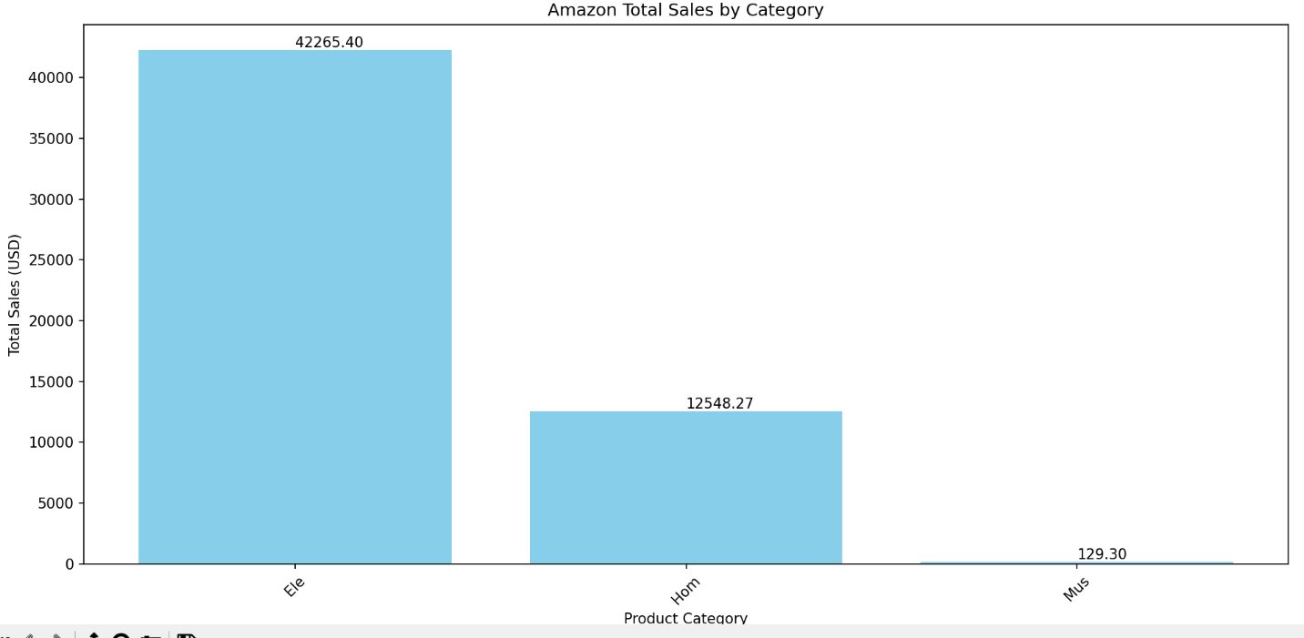
- Amazon’s total sales were calculated and visualized by product category. Electronics (“Ele”) was seen as the top-performing category, contributing $42,265.40 of the total sales, followed by Home (“Hom”) at $12,548.27.
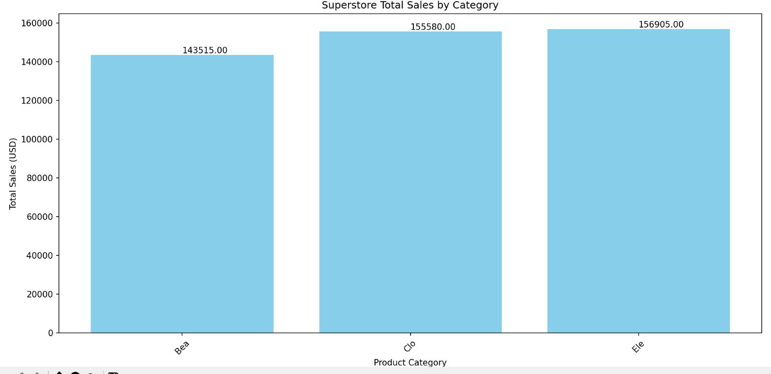
- Superstore’s total sales were more evenly distributed across categories:
  - Beauty (“Bea”): $143,515
  - Clothing (“Clo”): $155,580
  - Electronics (“Ele”): $156,905
Though it was evenly distributed, Electronics is the one on top with the most sales.
- Average Ratings by Category (Amazon)
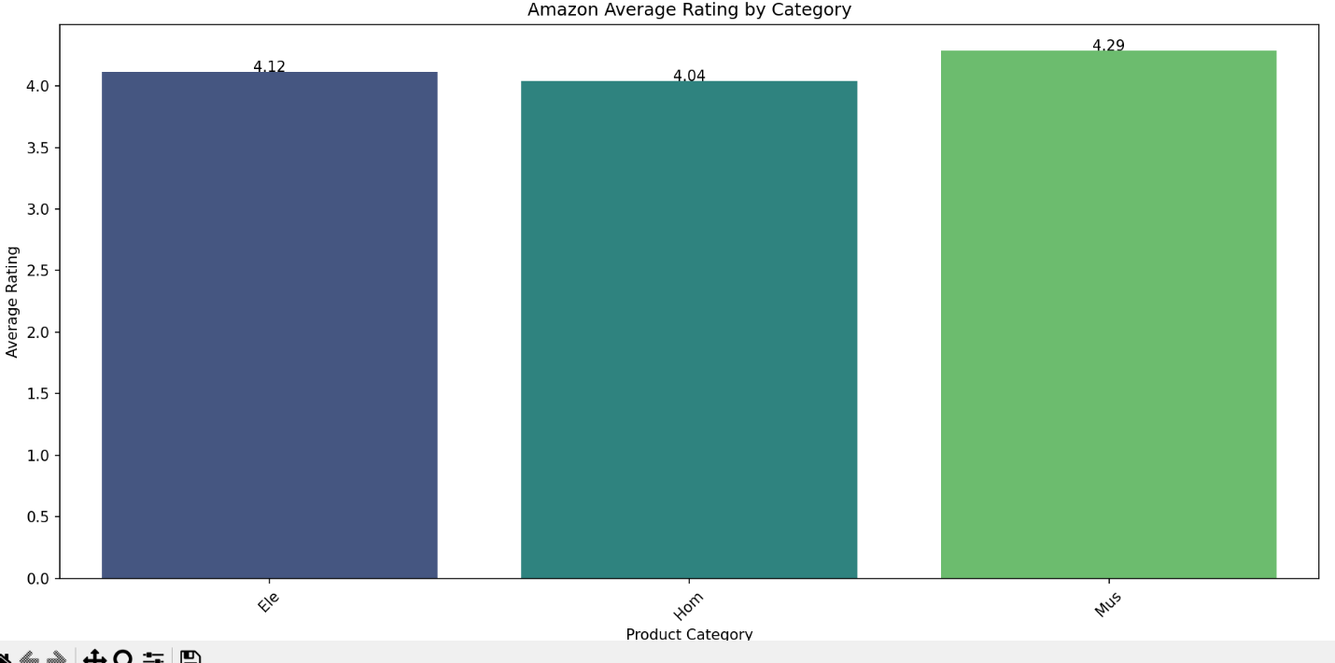
- Average customer ratings for Amazon categories were analyzed. Electronics had an average rating of 4.12, while Home and Music categories averaged 4.04 and 4.29. These high ratings indicate strong customer satisfaction, especially for Electronics. The average ratings of Electronics may be slightly lower than music due to more sales being from Electronics but, we can determine that a high average rating can be a contributing factor to sales in Amazon.
- Monthly Sales Trends (Superstore)
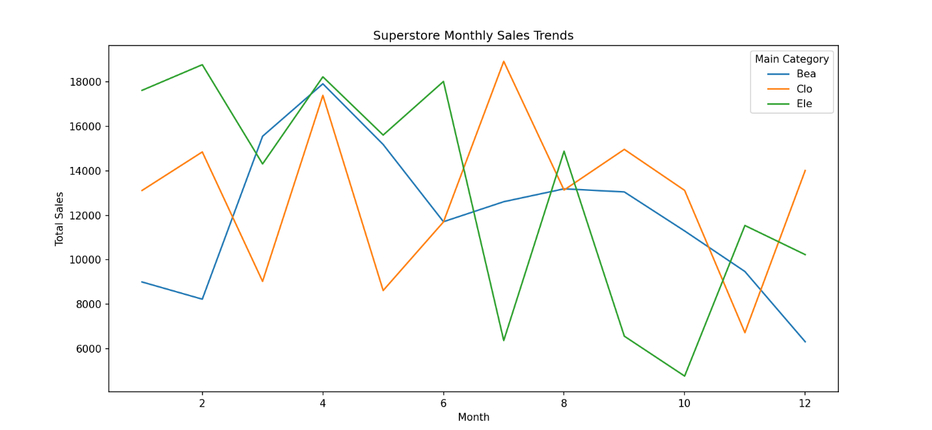
- A line plot of Superstore’s monthly sales revealed strong seasonality. Sales for categories like Beauty and Electronics peaked during the holiday months, which shows the importance of timing in sales performance. We noticed that the electronic sales started the year off high which could indicate the release of new products or a big sale on electronics. We notice a big decline from August to October which could indicate that students are back in school, and consumers may focus more on clothing.
Predictive Analytics
Predictive Question 1:
- Which product categories are likely to drive the highest sales for each platform?
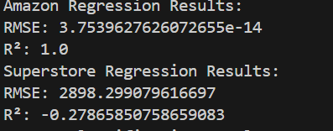
Amazon Regression Analysis:
- A regression model was built to predict sales based on the discounted price.
- Results:
  - RMSE: 3.7539627626072655e-14 (This may be low due to overfitting)
  - R²: 1.0 (perfect fit, likely due to limited features).
- Insights:
  - Electronics are the dominant contributing factor of Amazon’s sales. Including customer ratings as a feature increased sales understanding but highlighted overfitting concerns.
Superstore Regression Analysis:
- A regression model was built to predict sales based on monthly sales
- Results:
  - RMSE: 2898.30
  - R²: -0.28 (indicating underfitting).
- Insights:
  - Superstore sales show strong seasonal variation, but we could have analyzed more predictors like days of the week for better accuracy.
Predictive Question 2:
- What factors can classify categories as high- or low-performing?
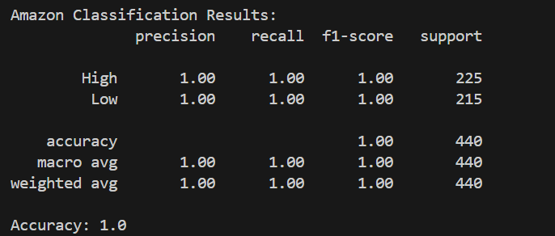
Amazon Classification Analysis:
- A Random Forest Classifier was used to classify Amazon categories into high-performing or low-performing based on sales.
- Results:
  - Accuracy: 100%
  - Key driver: Categories with higher ratings (4.0 and above) consistently performed better in terms of sales.
Findings:
- Amazon’s Electronics category dominates both in sales and customer ratings, indicating a clear strength in high-value, high-rated products.
- Superstore’s sales are driven by seasonality but unlike Amazon with electronics, the categories are evenly distributed which means no category was a dominant contributor in sales. Better inventory and promotion planning could boost performance.
Findings and Recommendations
1. Findings
- Amazon:
  - Electronics is the top-performing category, accounting for over 75% of sales.
  - High ratings (above 4.0) are a significant driver of sales.
- Superstore:
  - Sales are more evenly distributed across categories but are strongly influenced by seasonality.
  - Beauty, Clothing, and Electronics contribute equally to overall sales.
2. Recommendations
- Amazon:
  - Take advantage of high customer ratings by promoting top-rated products (e.g., Electronics).
  - Invest in product innovation for underperforming products where amazon can launch exclusive products in underperforming categories to increase the competition.
- Superstore:
  - Optimize inventory for peak months based on seasonality trends.
  - Introduce personalized promotions during seasonal peaks to connect with the customers and to maximize sales for top categories.
Conclusion
Based on the analysis, Amazon outperforms the retail store (Superstore) in terms of category-specific dominance, Electronics to be specific, which accounts for most of the sales and is supported by the high ratings from consumers. However, Superstore exhibits a broader balance in categories and strong seasonality trends, which, if used effectively, could drive comparable performance during peak seasons.
The key factors impacting sales are:
- Amazon: Customer ratings and the dominance of high-value categories like Electronics.
- Superstore: Seasonal trends and balanced category contributions.
Overall, Amazon’s focused category strength makes it the stronger performer in the future, but Superstore has opportunities to close the gap through strategic inventory and promotional planning during high-demand periods.

